**PROJECT PROPOSAL**

Our project seeks to develop an option analysis tool that provides pricing and analytics for options on stocks. We aim to use API data feeds for options, stocks and cryptocurrencies.

Product functionality:

* *API data feeds*
  + Establish API data feeds public, free data sets incl. real-time pricing for options, stocks and cryptocurrencies
  + Option pricing
    - https://www.quandl.com/
  + Stocks
    - https://alpaca.markets/
  + Cryptocurrency
    - https://www.alphavantage.co/documentation/
* *UI analytics*
  + User selects stock or cryptocurrency ticker
  + Application sources up-to-date stock/crypto price, profile (eg stock market cap, 52 week high/low, earnings date) and corresponding option pricing
  + User selects option term
  + UI displays:
    - Range of strike prices centered around current stock price
    - Bid-ask spreads for put and call options
    - Application calculates **implied volatility** based on Option price, strike price current price and Rate (using either black schole model or Numerical model or Numerical method like Montecarlo or **Binomial Tree Model**)
    - The ‘Greeks’ (delta etc), % ‘out-of-the-money’
* *Trading analytics*
  + User selects transaction (eg sell 100 1-month put options on Bitcoin with a $20,000 strike)
  + Application shows total premium
  + Ability to generate Monte Carlo simulations for option pricing based on implied vol
* *Sample screenshots*

**Option Chain Screen:**

* 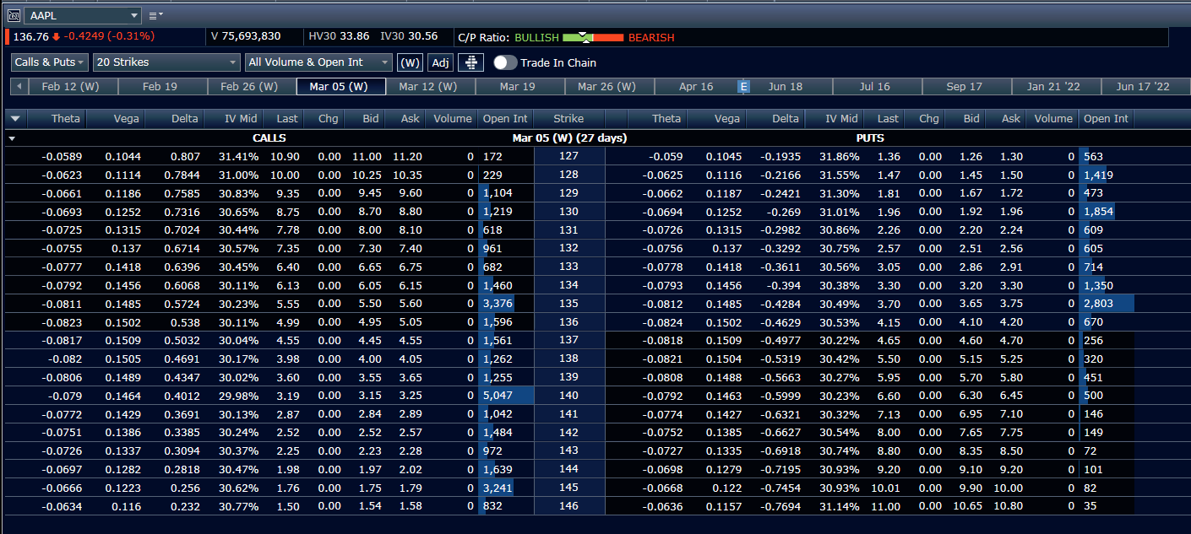

**Stock Description & Stats Screen:**

